Day 24 – Forecast Validation

Train Test split for Time Series :

For many machine learning tasks, We might randomly shuffle your data and split it into training and testing sets. However, this approach is fundamentally flawed for time series analysis.

The Problem with Random Splitting
Time series data has an inherent temporal order. Each observation depends on previous observations. Randomly shuffling the data breaks this important sequence, leading to several problems:
- Data Leakage: If you randomly assign data points, your training set might contain observations from the future relative to points in your test set. The model could inadvertently learn from future information it shouldn't have access to during a real forecasting scenario, leading to overly optimistic performance estimates. Imagine training a stock price predictor using data from next week to predict this week. It might look great in testing, but it's useless in practice.
- Loss of Temporal Structure: Models like ARIMA and SARIMA explicitly rely on the sequence and time dependencies (like autocorrelation) within the data. Shuffling destroys this structure, making it impossible for these models to learn meaningful patterns.
Therefore, evaluating time series models requires a different approach that respects the chronological order of the data.

Temporal Splitting: Maintaining Order
The standard method for splitting time series data is to use a cutoff point in time. All data before this point becomes the training set, and all data after this point forms the test set (also sometimes called the hold-out set).
- Training Set: Used to fit the parameters of your forecasting model (e.g., determining the p,d,q orders for ARIMA).
- Test Set: Used to evaluate the fitted model's performance on unseen future data. You compare the forecasts generated by the model (trained only on the training data) against the actual values in the test set.
This chronological split mimics a forecasting situation where you build a model based on past data and use it to predict future outcomes.
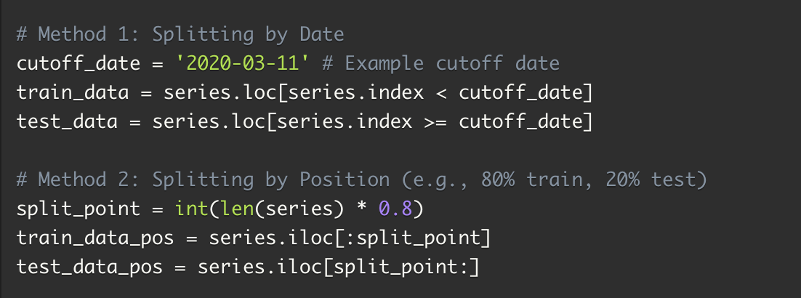
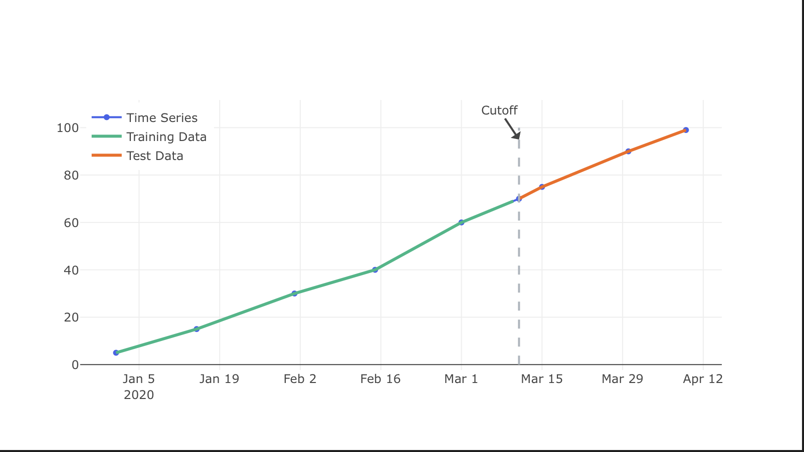

Choosing the Split Point and Test Set Size
How much data should you reserve for the test set? There's no single perfect answer, but here are some guidelines:
- Forecast Horizon: The test set should be at least as long as the maximum period you intend to forecast. If you need to predict 12 months ahead, your test set should span at least 12 months.
- Seasonality: If your data has seasonality (e.g., yearly patterns), the test set should ideally cover at least one full seasonal cycle to ensure the model's ability to capture it is properly tested.
- Data Availability: Common splits range from 70/30 (train/test) to 90/10. With very large datasets, a smaller percentage for the test set might still provide a sufficient number of observations. For smaller datasets, you need to ensure the training set is large enough to reliably estimate model parameters.
- Stability: Ensure the patterns (trend, seasonality) observed in the test set are reasonably representative of what was seen in the training set, unless you are specifically testing the model's robustness to changing patterns.

ERROR METRICES :

Mean Absolute Percentage Error (MAPE)
MAPE is defined as the percentage of the average of absolute difference between forecasted values and true values, divided by true value.
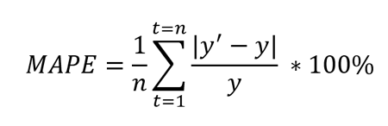
Where y’ is forecasted value and y is the true value. n is total number of values in the test set. Because of the in denominator, it works best with data without zeros and extreme values. If this value is extremely small or large, the MAPE value also takes an extreme value.
The lower the MAPE, the better the model is. Keep in mind that MAPE works best with data without zeros and extreme values. Like MAE, MAPE also understates the impact of large but infrequent errors due to extreme values. To deal with this problem, Mean Square Error can be used. This metric can gloss over problems to do with low data volume; see the last two metrics in this article to deal with that situation.

Root Mean Squared Error (RMSE)
This metric is an extension of MSE and is defined as the square root of mean square error.
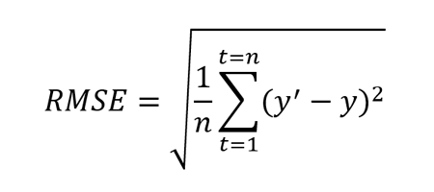
Where y’ is forecasted value and y is the true value. n is total number of values in the test set. Like MSE, this metric also penalizes larger errors more.
This metric is also always positive and lower values are better. One advantage of this calculation is that the RMSE value is in the same unit as the forecasted value. This makes it easier to understand compared to MSE.
RMSE can also be compared to MAE to determine whether the forecast contains large but infrequent errors. The larger the difference between RMSE and MAE the more inconsistent the error size.²This metric can gloss over problems to do with low data volume; see the last two metrics in this article to address that issue.

